**IDC Data Combination and Visualization Test**

The CSV data files provided are an example of real-world data collected from multiple sources. The aim is to showcase the relationships between technology vendors and the partners they work with to deliver their products and solutions. They are multiple attributes that align to partner companies that show case the partner capabilities.

**This test has two components:**

1 – Combine the datasets (8 files):

The CSV files are all interconnected through company (partners) and vendor IDs, with the files including multiple attribute associations with the respective items.

Outcome – use a python-based code to combine the datasets. Please provide the code in a text file

2 – Provide interpretive findings from the combined datasets in a visualized format. There is no wrong on right answer here. The idea is to use python code (and any libraries you wish) to extract what you feel are interesting insights from the data and show case those insights in a visual format. You can use any visual capabilities you wish that you believe would help a customer or user of the data quickly uncover valuable insights.

Provide a maximum of 5 visuals (can be showing the same insight in a different way, different insights for each, does not matter) showing correlation and cross collation of the relationships you identify in the dataset. e.g. example below

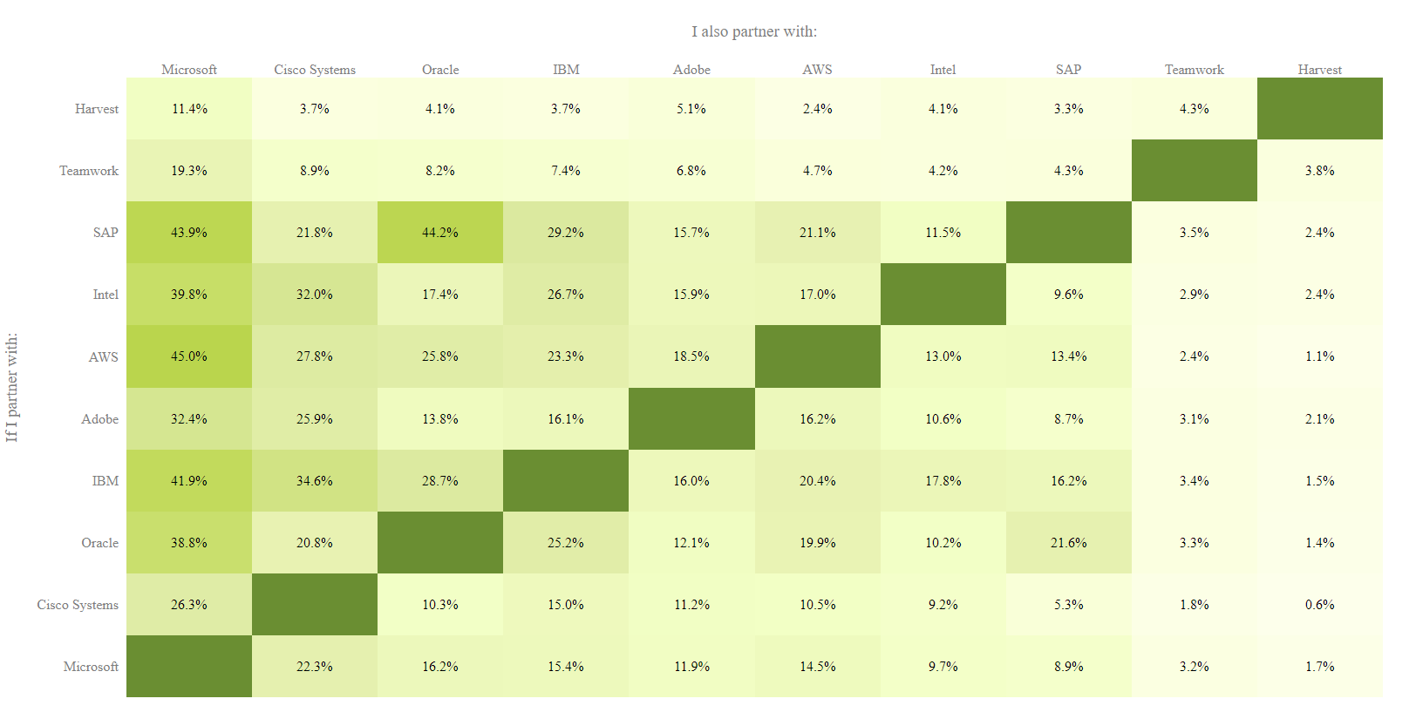

* Please provide a summary of the python libraries and technologies used to deliver your findings.
* Please include any python code and scripts in a text file for assessment.
* Please provide your visualized results in any format we can access or read in a browser or windows operated PC.
* Should you wish to use R libraries such as ggplot2 to support your visualization, please include 1/2 python examples together with your R examples. Once again, please include any code in a text file.
* You welcome to provide any context to your results, but not required